**FileZilla**

**Note to jai= explain domain name, or wherte ip address go, password and user name**

I will be using FileZilla as a too, to transfer files using FTP (File Transfer Protocol). This is an open source software and is both a FTP and FTPS. This is an effective tool to upload and download files and images.

**Overview and instructions.**

* ***File*** (tool bar)> Select***Site Manager***
* ***New Site (s***elect)- Include a name such as my first website
* ***Hostbox*-** enter FTP address i.e. if website is <http://www.myfirstwebsite.com> then the ftp address is as follows: [**ftp://ftp.myfirstwebsite.com**](ftp://ftp.myfirstwebsite.com) or [***ftp://myfirestwebsite.com***](ftp://myfirestwebsite.com)***.***
* ***Port Box-*** leave as default ***21***
* ***Logon Type-*** select ***Normal***
* ***Username-*** enter if provided
* ***Password-*** Enter and select OK

**Figure: New Site**

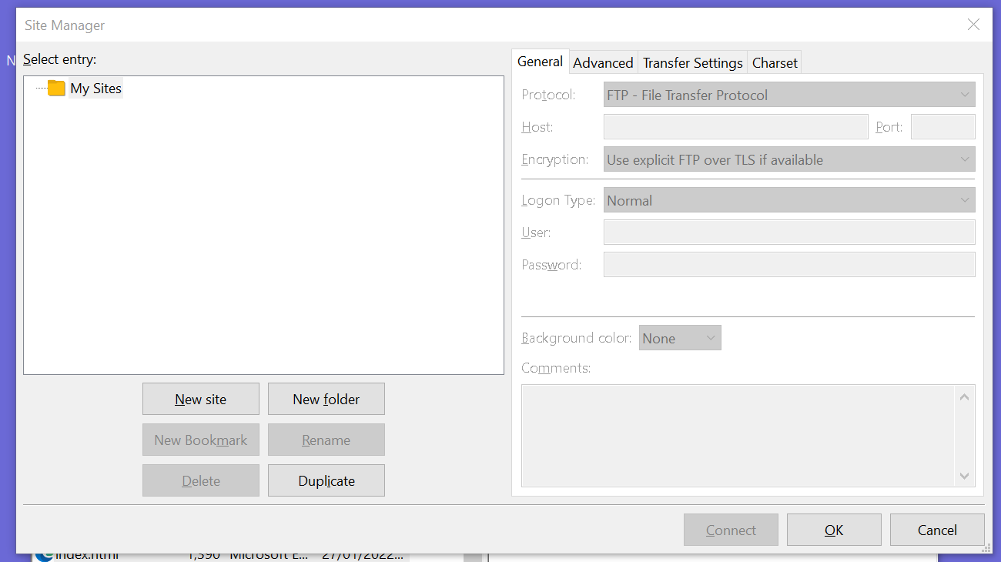

**Figure: File Transfer**

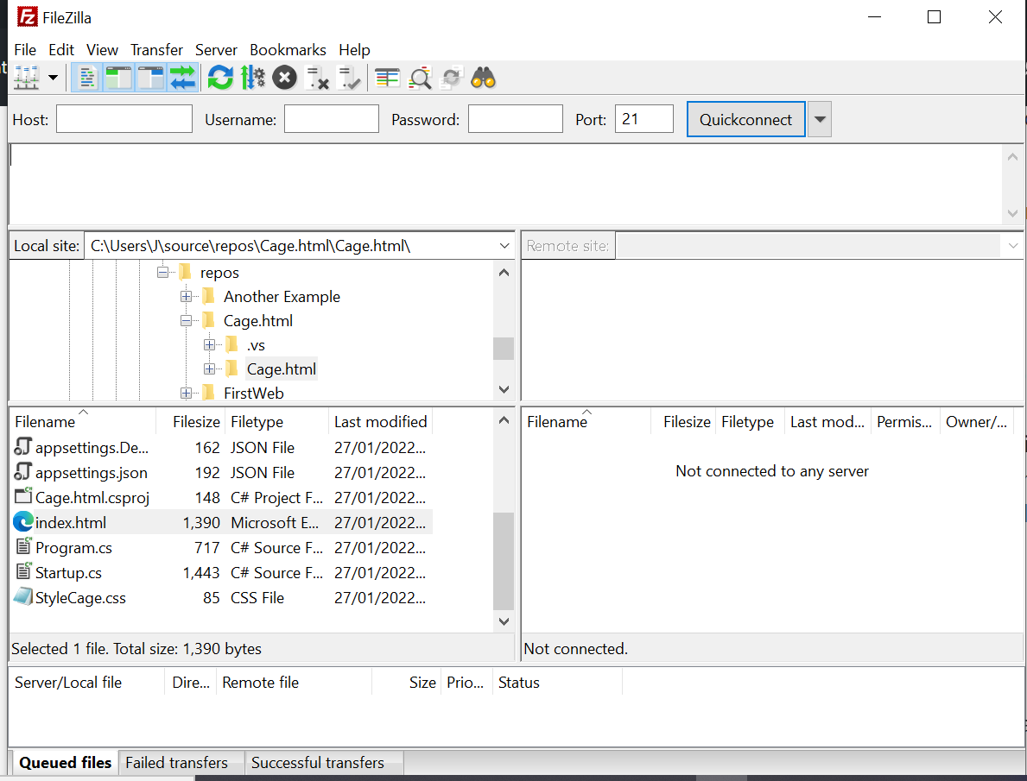

**Local and Remote**

These are directories where the files are stored

**Local Files**

Located in local directories of your compute such as the C:Drive

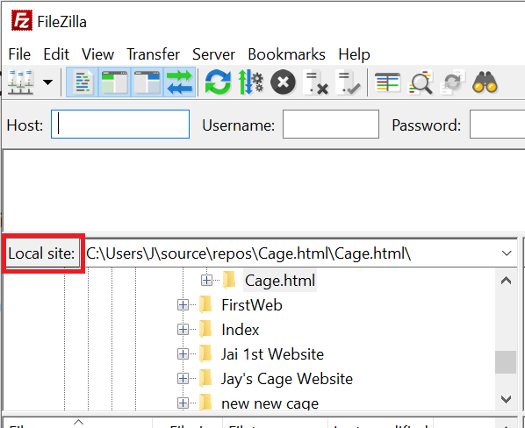

**Remote**

*These are files that a user can access that are located on a different computer. These resources are found using LAN (local area network) ,WAN (wider area network) or point to pint link*

